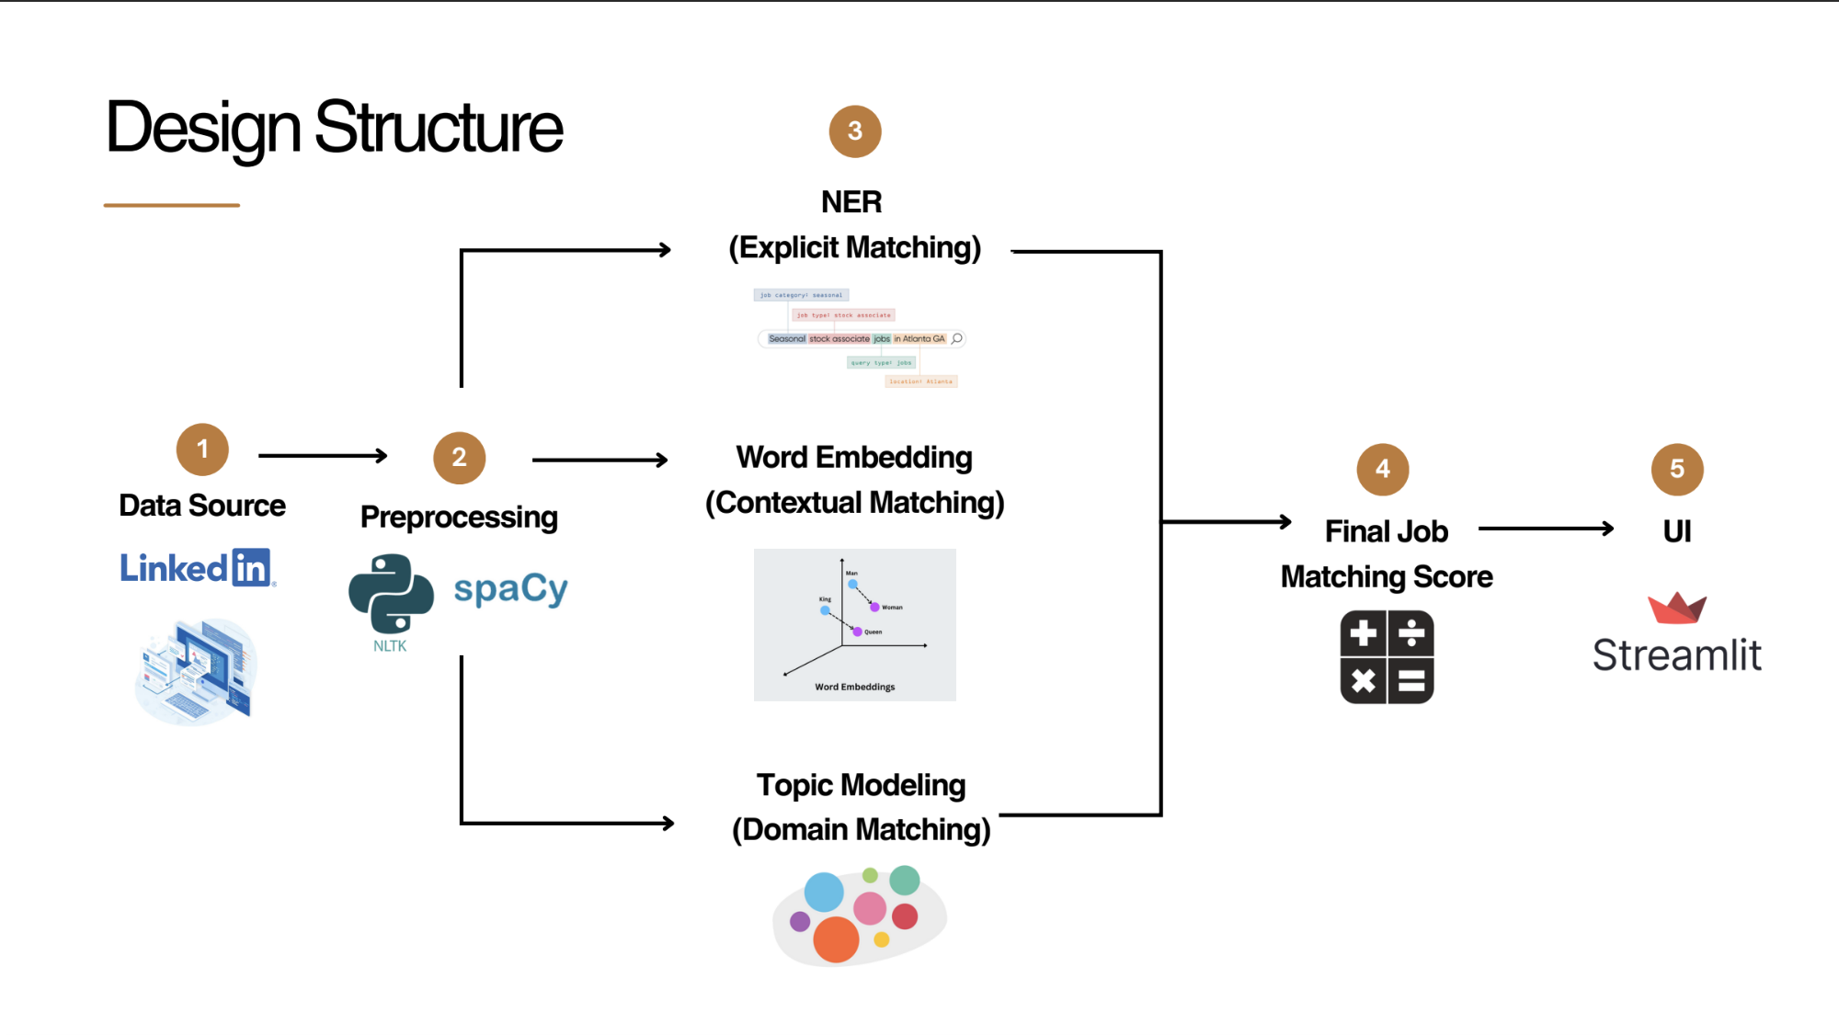
Note for everyone: Count the tokens of the text (e.g. 2000~), upload a resume, keep clean code for each process

- Resume → everyone provides 2-3 resumes? Ginny Kas Phil Boni Kibaek
- Dataset → combine all the data
Job scraping Code: linkedin.py Kibaek
Job scraping Output: scraps folder in github
Combine 2 datasets Code: KAS
Output: ???
- Preprocessing Resume Data Ginny
Input: Resume / Job data
Code:
Output: 1 clean chunk of Resume and Jobdata
- NER KAS
Input: 1 clean chunk of Resume and 1 clean chunk of job description
Code: ???
Output: Similarity
- Word Embedding Boni
Input: 1 clean chunk of Resume and 1 clean chunk of job description
Code: ???
Output: Similarity
- Topic Modeling Phil
Input: 1 clean chunk of Resume and 1 clean chunk of job description
Code: ???
Output: Similarity

Jobs (14,760 jobs) | Score
qwertyu | 0.545
rgas | 0.624

- Matching Score Kibaek
0.45*NER + 0.35*WordEmbeding + 0.2*Topic
Input: Similarity from NER, Word Embedding, and Topic modeling
Code:
Output:
- UI Kibaek
- Evaluation Method - ???

How we handle the data
Option 1: Split the experience from the resume, then match the resume later?

dsfndjfskj_0-5years

dsfndjfskj | 0-5years

Option 2: adding a filter from user input, then matching the experience range to the job description

Option 3: ignore the experience ////// Phil

dsfndjfskj_0-5years
dsfndjfskj_5-10years
dsfndjfskj_10-15years
dsfndjfskj_15-20years

dsfndjfskj
Add index

—-------------
UI
- Job
- Company

